Lab 1. Introduction to Data Dictionary

**1.1: Get the details of all the database objects and their types created by the current**

**user.**

Solution:

SELECT OBJECT_NAME,OBJECT_TYPE FROM ALL_OBJECTS WHERE OWNER='LAB2CTRG22';

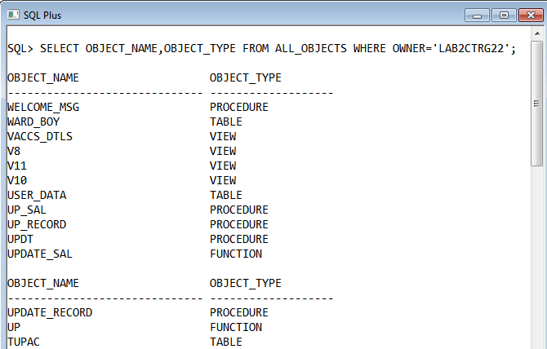

**1.2 Get the details of all the table names owned by current user**

Solution:

SELECT TABLE_NAME FROM ALL_TABLES WHERE OWNER='LAB2CTRG22';

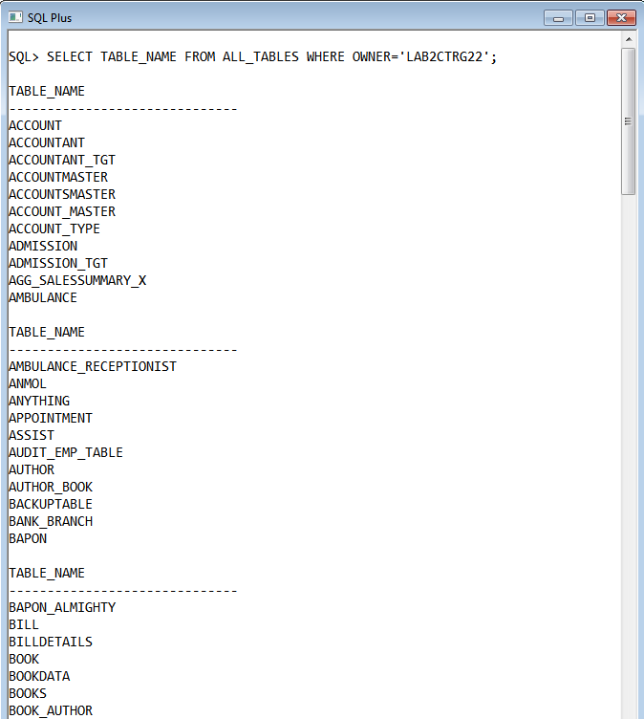

**1.3 Get the details of table names and corresponding column names**

Solution:

SELECT TABLE_NAME,COLUMN_NAME FROM ALL_TAB_COLUMNS WHERE OWNER='LAB2CTRG22';

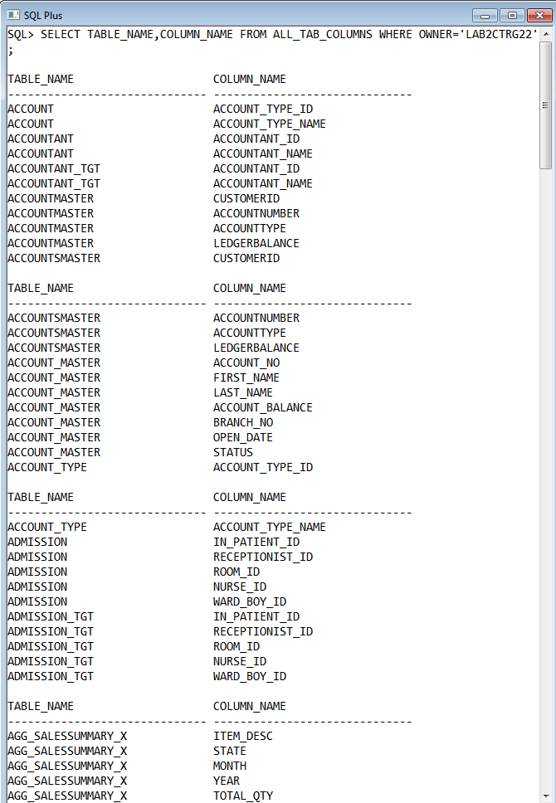

**1.4 Get the details of column names and corresponding constraint names**

Solution:

SELECT COLUMN_NAME,CONSTRAINT_NAME FROM ALL_CONS_COLUMNS WHERE OWNER='LAB2CTRG22';

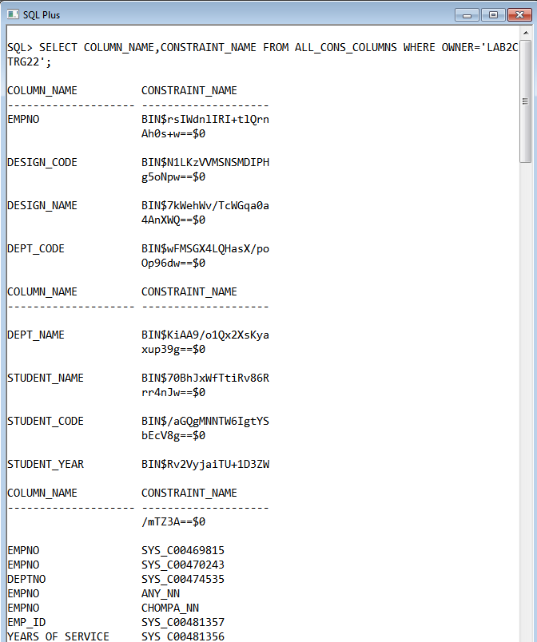

**1.5: Get the details of the constraints and corresponding table name.**

Solution:

SELECT CONSTRAINT_NAME,TABLE_NAME FROM ALL_CONS_COLUMNS WHERE OWNER='LAB2CTRG22';

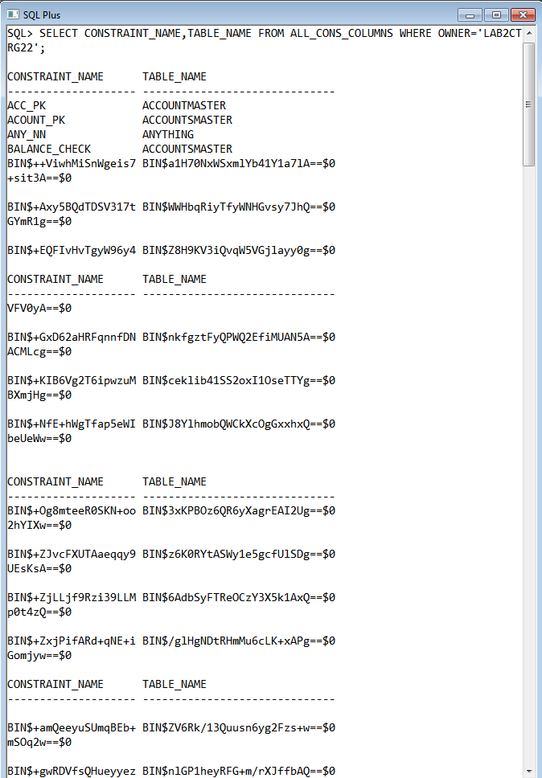

**1.6: Get the details of all the View names and corresponding Text of the same.**

Solution:

SELECT VIEW_NAME,TEXT FROM ALL_VIEWS WHERE OWNER='LAB2CTRG22';

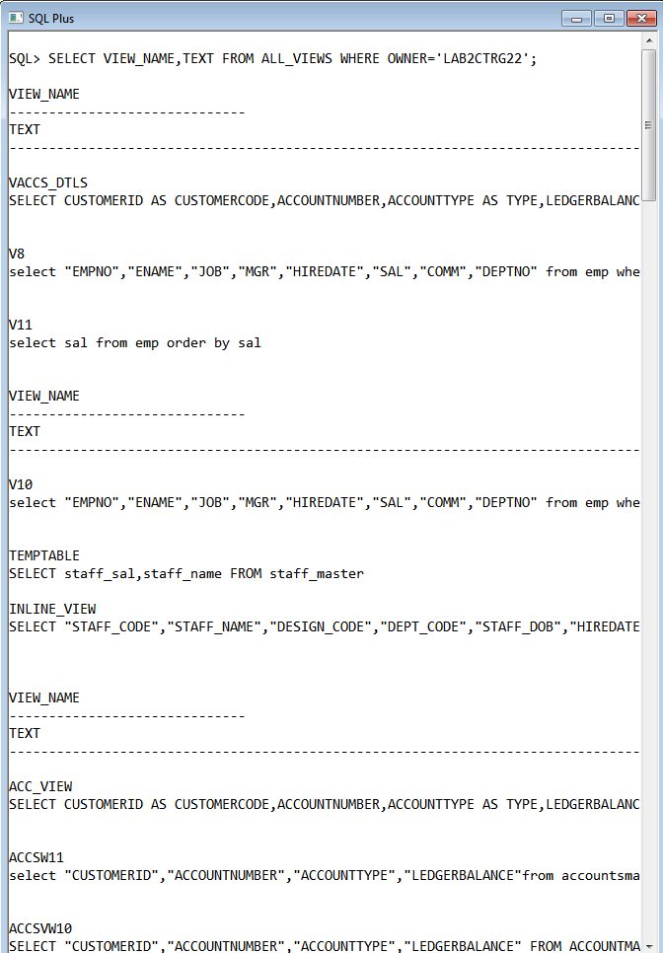

**1.7: Get the details of all the Sequence names and their last numbers reached so far.**

Solution:

SELECT SEQUENCE_NAME,LAST_NUMBER FROM ALL_SEQUENCES WHERE SEQUENCE_OWNER='LAB2CTRG22';

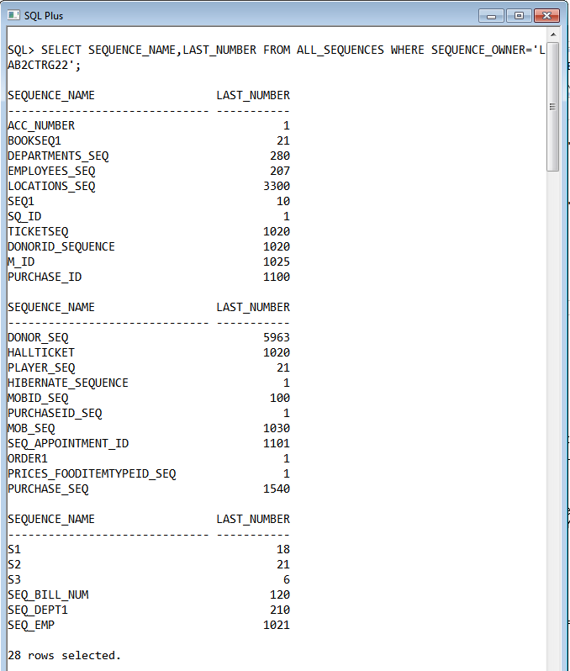

**1.8: Get the details of all the Synonym names and their parent object names.**

Solution:

SELECT SYNONYM_NAME,TABLE_NAME FROM ALL_SYNONYMS WHERE OWNER='LAB2CTRG22';

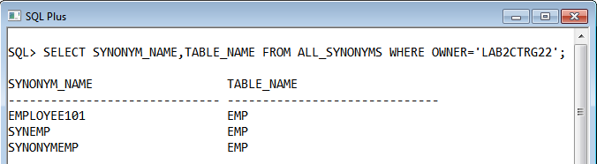

**1.9: Get the list of all the Index names**

Solution:

SELECT INDEX_NAME FROM ALL_INDEXES WHERE OWNER='LAB2CTRG22';

